PHASE 1
PROJECT INTRODUCTION & PLANNING

Objective:
To introduce the AI BlogNest project, identify the problem, define the project objectives, and plan the overall development process.

Project Introduction:
AI BlogNest is an AI-powered web application developed to generate high-quality blog content using Artificial Intelligence. The system uses Google Gemini AI to generate blog content based on the topic and category provided by the user.

Planning Activities:
- Selected the project title “AI BlogNest – Generate High-Quality Blog Content Using AI.”
- Identified the need for an AI-based blog content generation system.
- Defined the main objectives and features of the project.
- Selected the required technologies such as Node.js, Express.js, MongoDB and Google Gemini AI.
- Planned the overall system architecture and development workflow.

Technologies Planned:
Node.js
Express.js
MongoDB
Mongoose
Google Gemini AI
HTML
CSS
JavaScript

Expected Output:
A clear project idea, defined objectives, selected technologies and a basic development plan.

Phase Status:
Completed.

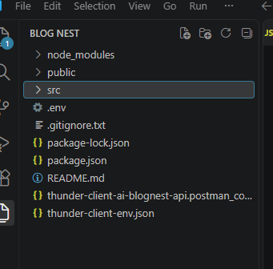
Figure 1.1: AI BlogNest Project Structure

